* <https://edu-umch.vercel.app/en>

1440 \* 768 : Safari

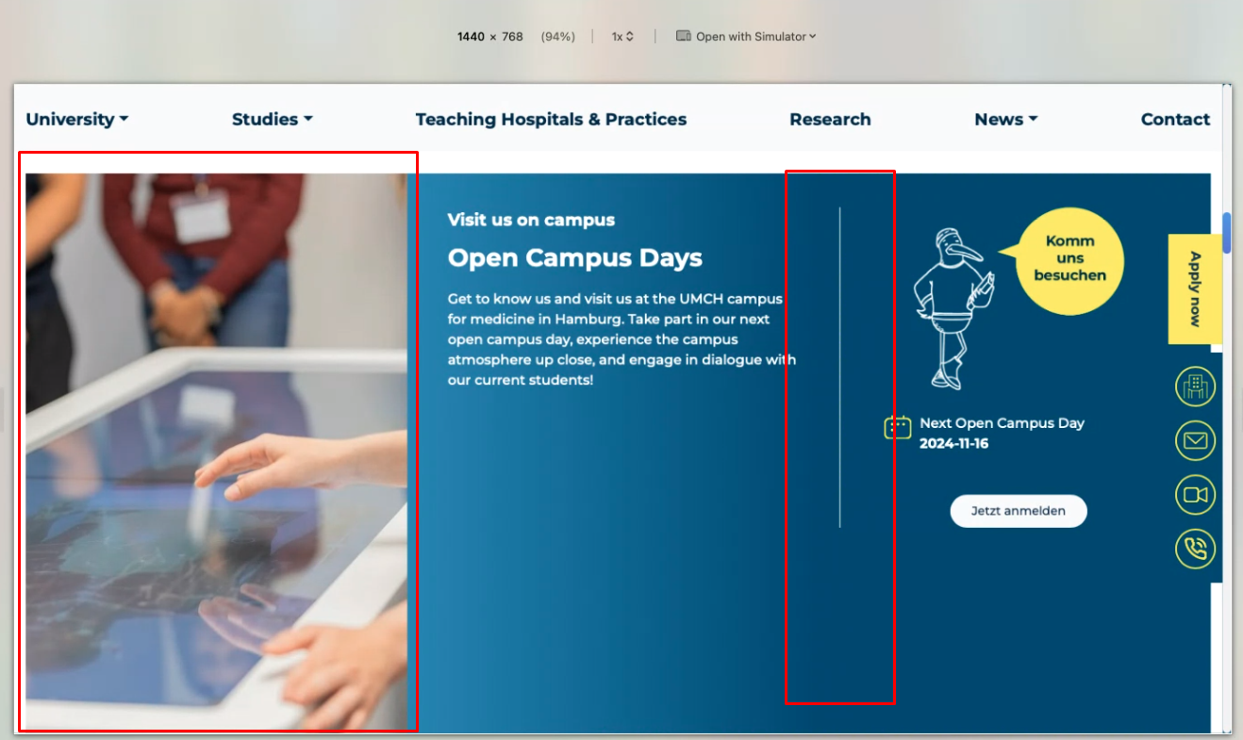

1440 \* 768 : Safari -> The entire image is not displayed.

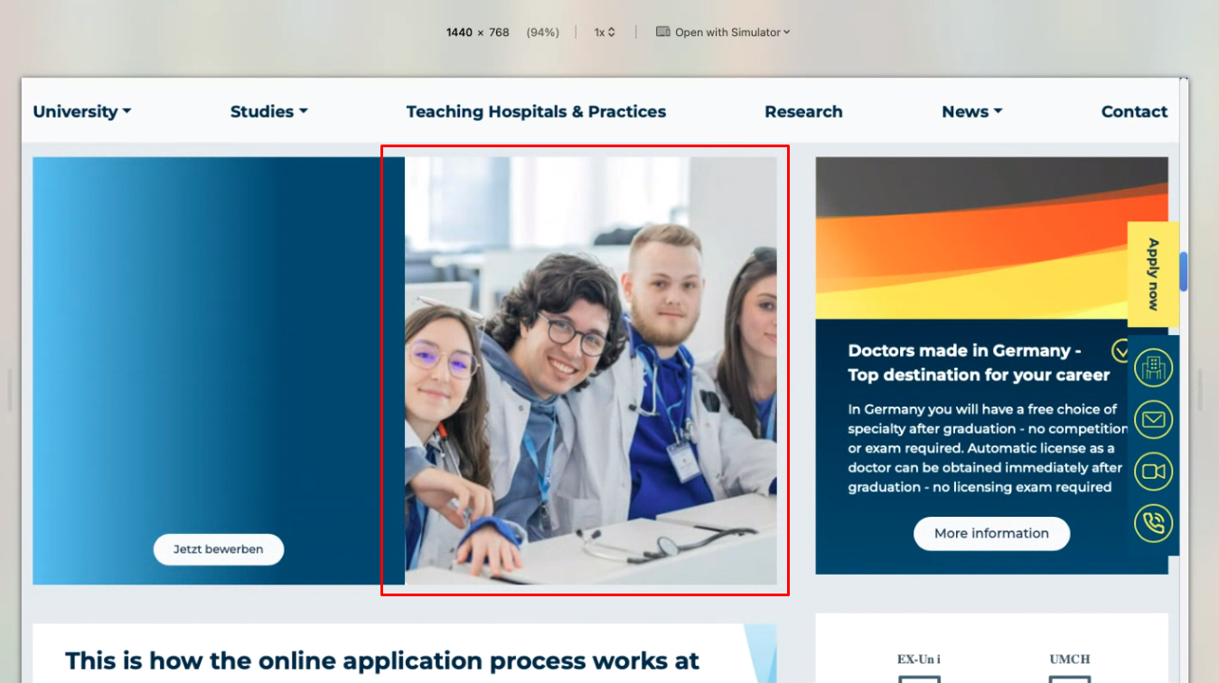

1024 \* 768 : safari & Chrome

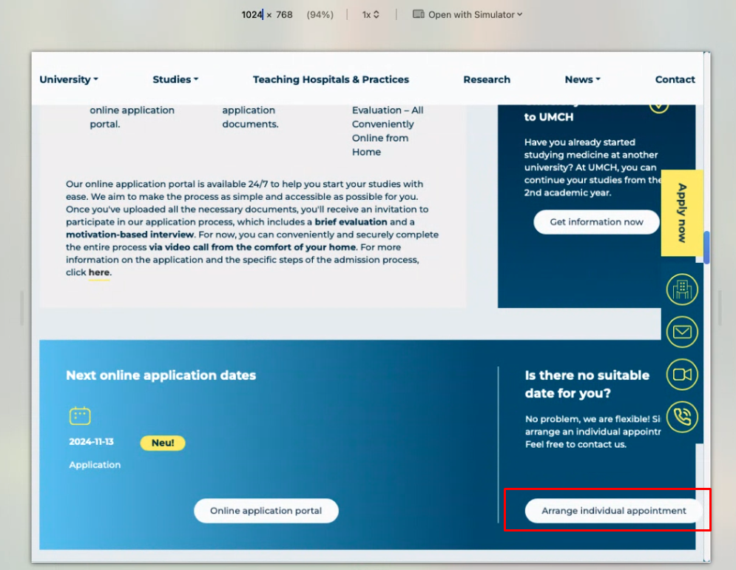

Please check 992 \* 840 and 993 \* 840 UI : this issue

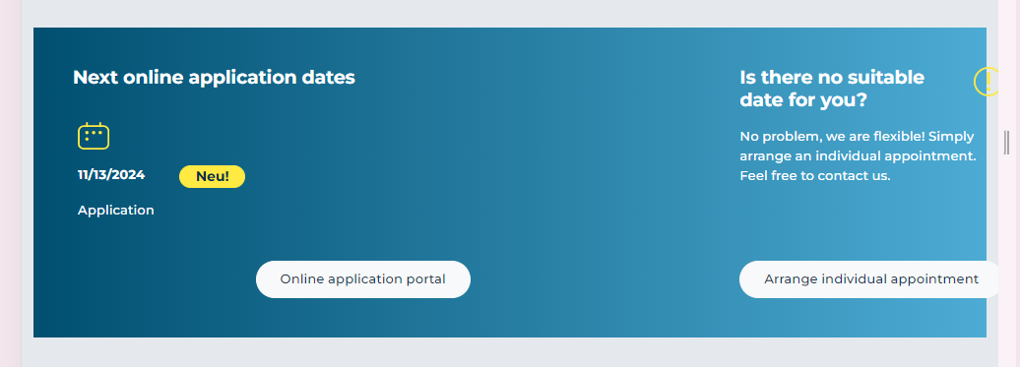

768 \* 768

The banner section is not same, something went wrong

768 \* 768 : Safari

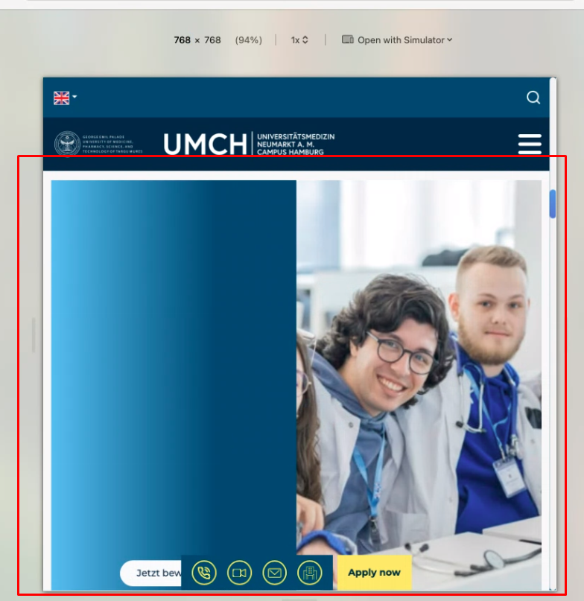

* <http://localhost:3000/en/university> : Safari -> the left image is not full image in all reponsive

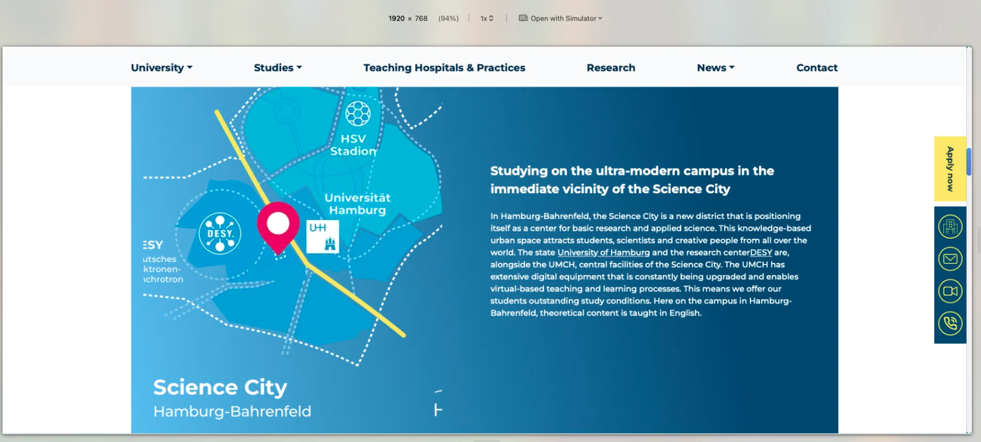

* <http://localhost:3000/en/the-campus>

in all responsive : Safari -> the image issue

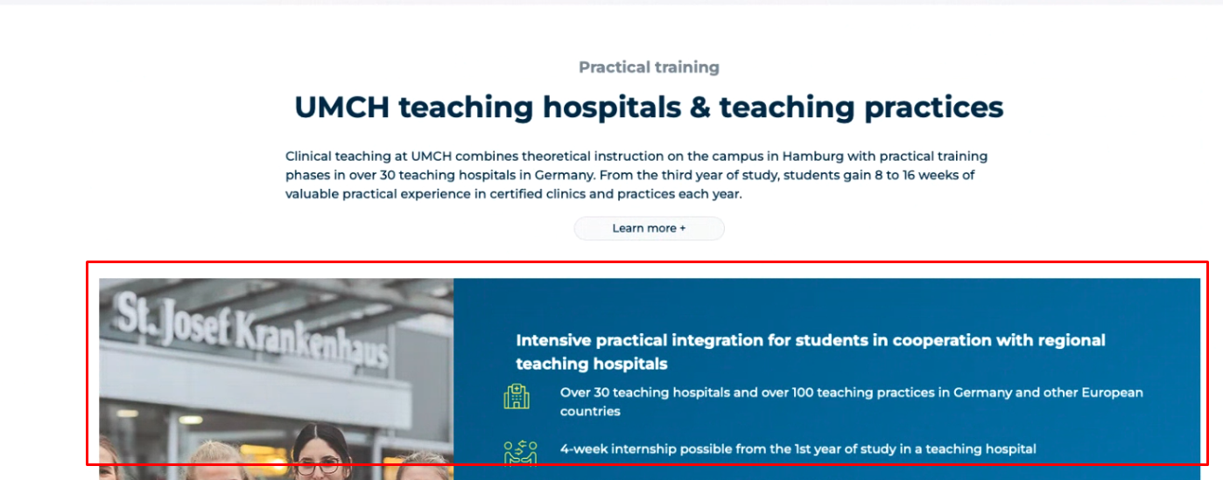

* <http://localhost:3000/en/application-information>

Chrome and Safari: 768 \* 720

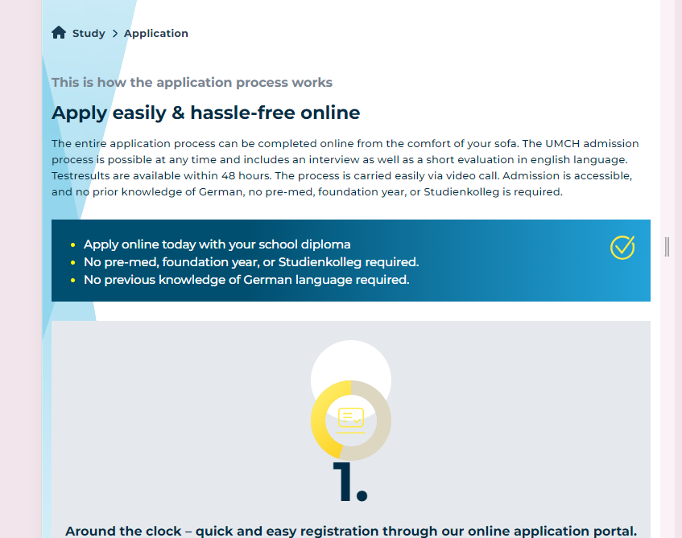

* <http://localhost:3000/en/events-and-termine>

1920 \* 720 : Safari

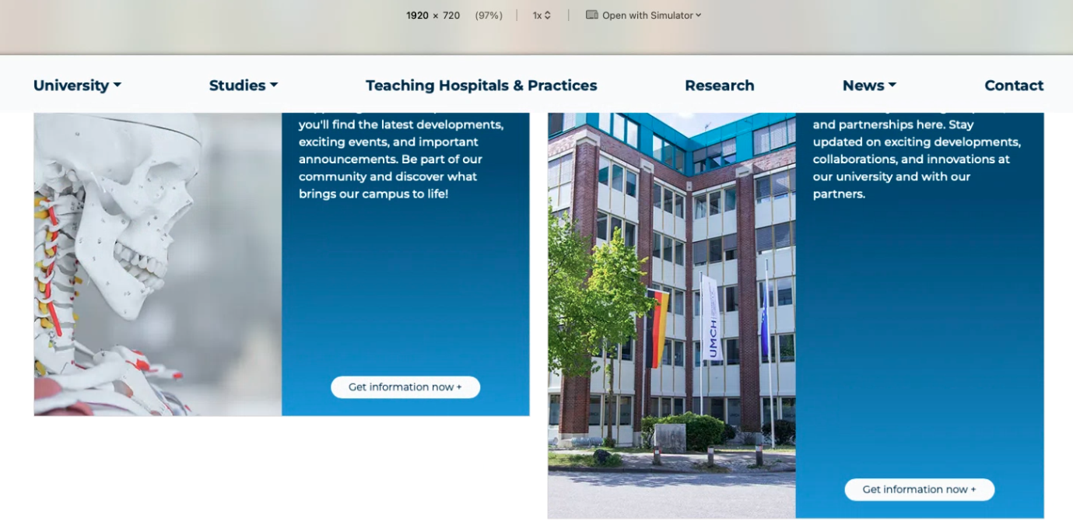

* <http://localhost:3000/de/events-und-termine/open-campus-day-09-11>, <http://localhost:3000/de/events-und-termine/individual-consultation-appointments-in-brussels>,

http://localhost:3000/de/vor-dem-studium

768 \* 840 : there is no icon in red part -> safari & Chrome

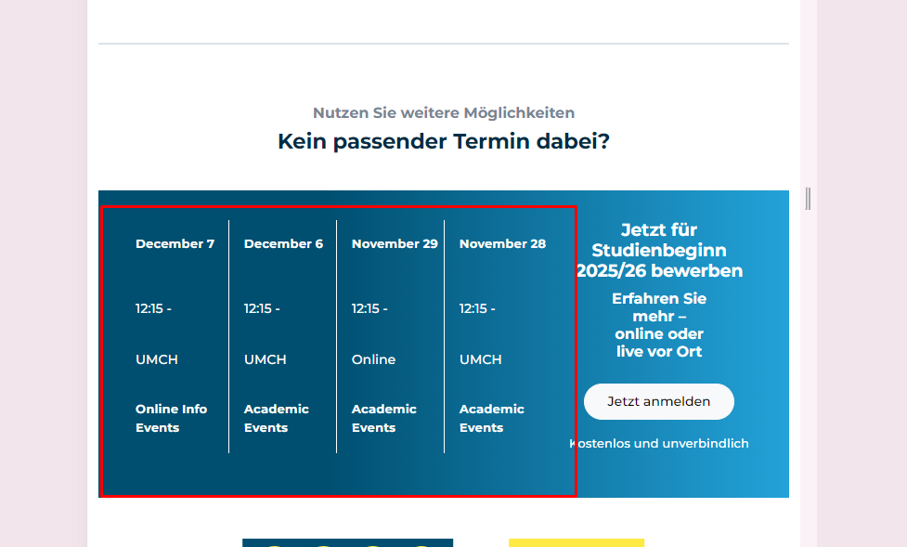

* <http://localhost:3000/de/events-und-termine/holy-jolly-christmas-lunch-break>

Need to check the red part image in all responsive : Safari & Chrome

